Experiment 25:-

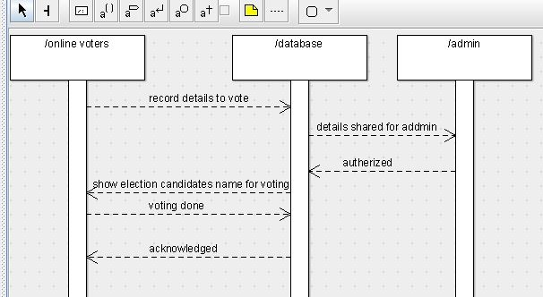Sequence diagramactivity diagram class diagram 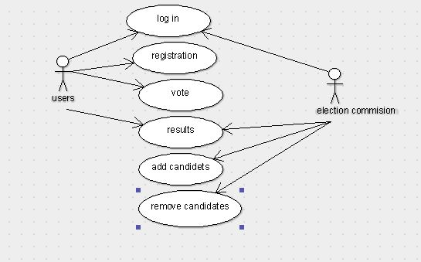 use casedeployment diagramcollabirationstate chart diagram

